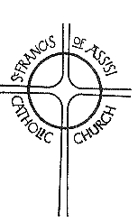 | Franciscan
 | Church of St. Francis of Assisi  277 Sandygate Road, Sheffield S10 5SD  Telephone 0114 263 0383  Email: stfrancisrcsheffield@gmail.com  parishcouncil26@yahoo.co.uk  Website: www.stfrancisrc-sheffield.org.uk  Registered Charity No. 512021  Parish Priest: Fr Kevin Thornton  Parish Deacon: Stephen Parker | THE SECOND SUNDAY IN  ORDINARY TIME  PEACE SUNDAY  Sunday 17th January 2021  Year B - Psalter week 2  (People of the Parish)

Under the rules for the current lockdown, CATHOLIC CHURCHES CAN REMAIN OPEN for communal worship. St Francis Church will be holding Mass on Sunday as usual. If this changes, you will be informed when you try to book a place.
If you want to attend MASS ON SUNDAY, you must book by emailing massatstfrancis@gmail.com by 6pm on Wednesday stating how many places you would like. If space is available, you will receive the offer of a place by Thursday evening. You MUST reply to accept your places and confirm you are symptom free. Anyone without email, can call 07901 166218 between 9am and 5pm Monday to Wednesday.
There will be a box in the narthex for the OFFERTORY COLLECTION. Alternatively, you can make your offertory donation directly to:
- Account name: Diocese of Hallam St Francis Sheffield
- Sort Code: 40-41-07.
- Account Number: 21094343
If you are able to Gift Aid your offering and have not already signed a Gift Aid Declaration, please contact Edmund King at e.king@sheffield.ac.uk.
RULES FOR MASS ATTENDANCE
- You must sanitise your hands when entering.
- Wait at the inner door to be directed to a seat.
- Face coverings must be worn throughout Mass.
- Communion will be brought to you in your seat and should be received in silence.
- Remain in your seat until told to leave via the hall.
- Please do not gather outside and leave as quickly as possible.
St Francis Church is registered as a ‘venue’ with NHS COVID-19 TEST AND TRACE APP. Please scan the QR code in the narthex if you have the app.
VURCH (Virtual Church) will continue through Zoom on Sundays at 11am. Login details are as follows:
- Meeting ID: 700 601 109
- Password: StFrancis
Everyone is welcome.
You can join a LIVE-STREAM OF THE MASS from St Marie’s Cathedral at 11am on Sunday and 8am Monday to Saturday at https://stmariecathedral.org/.
PLEASE PRAY for John Rowan, Ann Bright, Jean Fahy, Jo Chadwick, JH and Pam Harris, who are sick, for Muriel Burke, lately dead and for all whose anniversaries occur about this time.
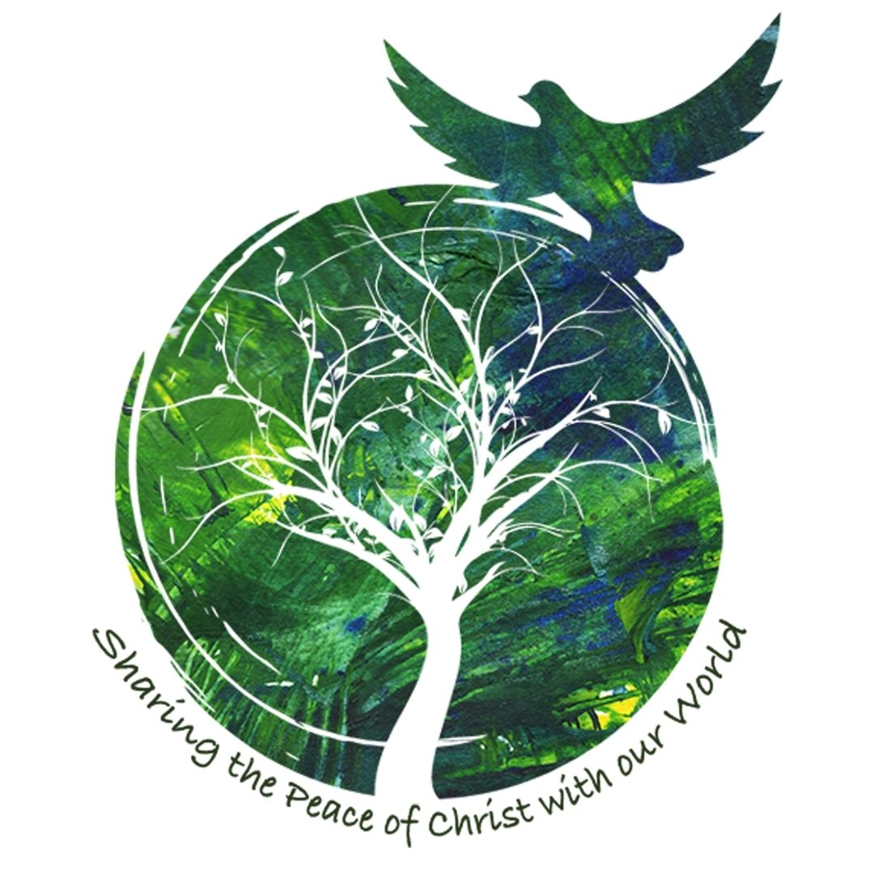Today is the DAY OF PRAYER FOR WORLD PEACE. This year, Pope Francis asks us to think about ‘A Culture of Care as a Path to Peace’.
“How many resources,” he says, “are spent on weaponry, especially nuclear weapons, that could be used for more significant priorities such as ensuring the safety of individuals, the promotion of peace and integral human development, the fight against poverty, and the provision of health care.” Pope Francis calls on us to “strive daily, in concrete and practical ways, to form a community composed of brothers and sisters who accept and care for one another.”
There is a basket in the narthex if you wish to support the work of Pax Christi. You can also donate at https://paxchristi.org.uk/peace-sunday-2021/.
The week of PRAYER FOR CHRISTIAN UNITY runs from 18th to 25th January. The theme this year is ‘Abide in my love and you shall bear much fruit’ based on John 15: 1-17. You can find suggested readings and prayers for each day at www.cbcew.org.uk/home/events/wpcu-2021/.
Next Sunday is SUNDAY OF THE WORD OF GOD. This was started to encourage us all the read the Word Of God i2n the Bible, the Sacred Scriptures. Have you got a Bible at home? When was the last time you opened it and read God’s Word?
RACIAL JUSTICE SUNDAY is on 31st January. There will be a collection basket in the narthex.
The Catholic Truth Society (CTS) are currently offering copies of the SUNDAY MISSAL FOR 2021 for £1.99 (plus £1.95 for delivery). You can order a copy at: www.ctsbooks.org/.
There are 70 million people around the world displaced from home. In 2015, Pope Francis asked every Catholic community to consider hosting a refugee family. A small group from St Francis, Mother of God, St Vincent’s and St William’s has been thinking about how we could respond and we would like RESETTLE A REFUGEE FAMILY in our community. But we can’t do it without your help. To prepare for the family’s arrival, and to help them settle in, we need lots of volunteers. Could you help refurbish and furnish a home, be an interpreter, fundraise, help with legal or financial issues, find a school for the children or register the family for medical care and social security benefits or befriend the parents and children when they arrive? We need all of these skills and more. If would like to be involved, please contact Stephen Spooner on 2669726 or sfspooner@hotmail.com.
The POPE’S PRAYER INTENTION for January is Human fraternity - May the Lord give us the grace to live in full fellowship with our brothers and sisters of other religions, praying for one another, open to all.
Pope Francis has announced the YEAR OF ST JOSEPH to commemorate the 150th anniversary of the declaration of St Joseph as Patron of the Universal Church.
RESTORED LIVES is a course for anyone who is divorced or separated. It helps people to move forward from the breakdown of a serious relationship, to live a full life, free from past issues. The course will be held from 6pm to 8pm over six weeks on ZOOM, starting on Wednesday 3rd February. It costs £20 (free for unemployed). Contact stym@hallam-diocese.com to book or for more information.
THE FRANCISCAN is currently only available electronically by email or from the website. Please contact pauljayne.middlemas@gmail.com to be added to the mailing list.
You can order a copy of the CATHOLIC UNIVERSE to be delivered to your home from www.thecatholicuniverse.com. A three-month subscription costs £25.
ST FRANCIS FILM SOCIETY (SFFS) is an informal film club meeting on Tuesday evenings. They meet on Zoom, watch a film in their homes and then reconvene for discussion about the religious or moral issues raised. If you are interested, please contact Richard Webster on rpwebsterdesign@gmail.com.
St Marie’s Cathedral has a range of CHILDREN’S LITURGY resources on its website each week at https://stmariecathedral.org/mass-worship/childrens-ministry/. There is a 3 minute YouTube video illustrating the Gospel and a 15 minute children’s liturgy including prayers and discussion. There is also an activity sheet to print.
The HALLAM YEAR BOOK AND ORDO has ceased publication. The material that was included will be available at https://hallam-diocese.com/.
The MASS READINGS for this week are:
- 1 Samuel 3: 3-10, 19
- 1 Corinthians 6: 13-15, 17-20
- John 1: 35-42
SCRIPTURE NOTE:
This year the ordinary Sunday gospel readings are taken from Mark, and this provides us with a full picture of that gospel. But Mark is the shortest of the gospels, and is not quite long enough, so just occasionally a reading from John slips in to enrich our understanding of the meaning of Jesus’ words and actions. Today’s story is about the call of the first disciples and takes place in the Jordan valley, where John was baptising. The first two to be called are disciples of John, so they had already joined his group who were waiting for the Messiah. They were ready when John pointed him out. It is striking that Jesus first calls them to be with him, and that they remain with him for a time. In our call to follow Christ, first comes prayer and getting to know him, before we can actively work for Christ and bring others to share his joy. Only after this repose with the Lord do the disciples sprint off in their enthusiasm and bring others to join in the benefits they have received from that tranquillity and refreshment which comes from keeping company with Jesus.
What is God calling you to do?
REFLECTION God’s call
God’s call is mysterious; it comes in the darkness of faith. It is so fine, so subtle, that it is only with the deepest silence within us that we can hear it. And yet nothing is surer or stronger, nothing is so decisive and overpowering as that call. This call is uninterrupted: God is always calling us.
PRAYER FOR PEACE
Lord we pray for the ability to be gentle; the power to be forgiving; the patience to be understanding; and the perseverance to accept the consequences of holding on to what we believe to be right.
Father may we place our trust in the power of goodness to overcome evil and the power of love to overcome hatred.
Lord we pray for clear vision so as to see and the faith to believe in a world free from violence, a new world in which fear shall no longer lead men or women to commit injustice, nor a world where selfishness makes them bring suffering upon others.
Help us to offer our whole life and thought and energy to the task of making peace, praying always for the inspiration and the power to fulfil the destiny for which we and all men and women were created.
Amen.

